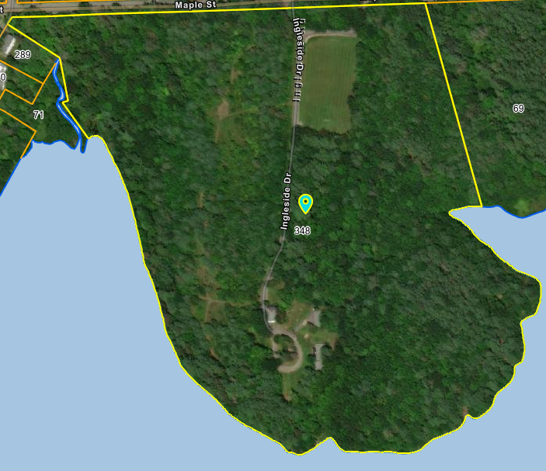

Porta Potties

Fields by Cul de Sac

Parking Lot

Soccer Field

Amphitheater