Town of Winchendon Massachusetts

American with Disabilities Act, ADA
Inventory and Transition Plan

February 2020

Prepared by: The Department of Planning and Development

Winchendon, MA 01475

Contents

Introduction Inventory/Transition Plan
- Existing Facilities Inventory
  - Buildings
- Sidewalks and Curbs
- Parks and Recreation Areas
- New Construction, Alterations and Additions
- Maintenance of Accessible Features
- Communication
- Policies, Practices, and Procedures
- ADA Compliance Documents Designation of ADA Coordinator Public Notice
Grievance Procedure

Appendices
Town Hall Offices Evaluation
Municipal Buildings Evaluation
9-1-1 Disability Indicator Form Application for Employment Resources for the disabled

2

3
3
6
6

8
9
10
11
13
14
15
16

17

Introduction

The Americans with Disabilities Act gives civil rights protections to individuals with disabilities similar to those provided to individuals on the basis of race, color, sex, national origin, age, and religion. It guarantees equal opportunity for individuals with disabilities in employment, transportation, State and local government services, telecommunications, and in the goods and services provided by businesses.

Small towns offer a variety of essential programs and services that are fundamental to the public and to everyday American life. Although the range of services offered by small towns varies, it is essential that people with disabilities have the opportunity to participate in the programs and services that towns offer. Applying for a building permit or business license, playing ball in the local park, marching in the Memorial Day parade, attending an annual street festival or a town meeting, or calling 9-1-1 for emergency police, fire, or rescue all are typical town programs, activities or services covered by the Americans with Disabilities Act or ADA. The ADA gives people with disabilities an equal opportunity to participate in the mainstream of public life offered to all Americans.

Title II of the ADA applies to State and local governments, including towns and townships, school districts, water districts, special purpose districts, and other small local governments and instrumentalities. It prohibits discrimination on the basis of disability in all services, programs, and activities provided by towns. Thus, people with disabilities must have an equal opportunity to participate in and benefit from a town's services, programs, and activities. To accomplish this, the ADA sets requirements for town facilities, new construction and alterations, communications with the public, and policies and procedures governing town programs, services, and activities.

The Town of Winchendon is committed to providing fair and appropriate access to all its residents, employees and guests. This report was prepared by the Department of Planning and Development in accordance with the town's responsibilities under the ADA. Department staff visited buildings, reviewed policies, inquired as to programs and activities, checked public postings, and interviewed department heads as part of the evaluation.

Tracy Murphy
Director of Planning & Development

- Existing Facilities Inventory

When programs, services, or activities are located in facilities that existed prior to January 26, 1992, the effective date of Title II of the ADA, towns must make sure that they are also available to persons with disabilities, unless to do so would fundamentally alter a program, service, or activity or result in undue financial or administrative burdens. This requirement is called program accessibility. When a service, program, or activity is located in a building that is not accessible, a small town can achieve program accessibility in several ways. It can:

  - Relocate the program or activity to an accessible facility,
  - Provide the activity, service, or benefit in another manner that meets ADA requirements, or
  - Make modifications to the building or facility itself to provide accessibility.

Thus, to achieve program accessibility, a small town need not make every existing facility accessible. It can relocate some programs to accessible facilities and modify other facilities, avoiding expensive physical modifications of all town facilities.

- Buildings

Town Hall

Town Hall (c. 1840), located at 109 Front Street in the commercial center of town, is listed on the National and Massachusetts Registers of Historic Places. Renovations over the years have improved accessibility to the point where the building is accessible.

In 1998, the town used Community Development Block Grant funds to install an elevator which provides accessibility to all floors of town hall, and construct two accessible restrooms on the second floor. This addition was important in that it provided people with disabilities access to the second floor auditorium where public meetings are held. In the auditorium a hearing device is available. Public meetings are broadcasted live via the local cable network station.

There are two accessible parking spaces in the municipal parking lot adjacent to the town hall. The spaces are marked for handicap use, but it is not marked "van accessible." There is no sign to direct visitors from the main entry on Front Street to the accessible entry on Pleasant Street side of the building.

Transition Plan: The parking spaces can be converted to van accessibility by adding a sign. The remaining items can also be completed with minimal expense and in a timely fashion with the installation of signage. The Town Manager's office is responsible for implementation.

Streeter and Poland Schools
The Streeter School (c.1939) closed in 1961. The first floor is currently being leased to the local veterans' agency as a recreation center. A wheelchair ramp provides access to the front door; however, the door is less than 32" wide, it does not have an accessible handle/latch system, and there is no buzzer system to request access. There is one unmarked accessible restroom; it has no audible/visual fire alarm. The second floor of the building is closed and not accessible.

Also a former school, the Poland School (c.1924) was vacated in 1961. It was occasionally used by the Fire Dept. for training purposes but is no longer utilized for any activities and is not accessible to the public.

Transition Plan: By replacing the door and handle system, the first floor of the Streeter School building would be accessible. The restroom needs to have a sign and an audible/visual alarm installed. There are no plans to further renovate or use either of these buildings for municipal functions.

Old Murdock High School - Winchendon Senior Center
Old Murdock High School (c.1887), listed on the National and Massachusetts Historic Registers, was last used for school offices in 1961. The Winchendon Council on Aging now operates out of the building. An Architectural Barrier Removal project for the Old Murdock School was conducted in 2007 utilizing funding from the Department of Housing and Community Development, (DHCD), Small Cities Grants FY 06 grant round. The project added two dedicated Barrier Free parking spaces, a new entry door, installation of a five-stop elevator, modification to two restrooms and modifications to door hardware.

Former Police Department Headquarters
The former Police Department Headquarters, (c.1876), is adjacent to Town Hall and shares the parking lot. The space is primarily used for storage: access is limited to town personnel.

Police Station
The Town's Police station, located at 90 Central Street, was renovated in 2016 and fully complies with ADA requirements.

Fire Department
The Town's Fire station, located at 405 Central Street, was built in 1978 and fully complies with ADA requirements.

Beals Memorial Library
Beals Memorial Library (c.l913), 50 Pleasant Street, is listed on the National and State Registers of Historic Places. The building is not ADA compliant; there is no accessible entrance; upper floors are reached by stairways; the bathrooms are not accessible; there is no parking on site however, accessible parking is available adjacent to the property. Upon request, library personnel will deliver and pick up books from persons at curbside and/or their homes.

Transition Plan: Construction of the Beal’s Memorial Library Access Project begins in May 2017. The project includes an ADA compliant walk leading to a new main entrance at the library’s lower level where an elevator will provide access throughout the building. Access will include after-hours use of the Main Hall on the upper level as well as a future Children’s Library on the lower level. ADA compliant restrooms will be located on the lower level. Construction will be complete by the end of 2017. The Library Trustees are responsible for project implementation.

Sewer Treatment Plant
The treatment plant is fully accessible but is not open to the public; access is limited to department personnel.

Department of Public Works
The Town's Department of Public Works oversees the town garage, the water department and the cemetery. The town garage and water treatment plant are not open to the public; access is limited to personnel. The main entry door to the garage is not accessible however, the overhead doors provide ADA accessibility. The cemetery has paved and/or hard packed roads, there is no curbing and the terrain is predominately level.

Schools
The Winchendon School Department maintains a separate ADA inventory and transition plan for its facilities. The contact is the Superintendent's office at 978-297-0031 or the Special Education Department at 978-297-1850.

- Sidewalks and Curbs

As a rural town, there are a limited number of sidewalks and most are in the downtown business district and adjacent residential neighborhoods. While the town installed ADA compliant curb cuts in its downtown business district in 1988, they are now in disrepair and do not meet current ADA requirements. In addition, few sidewalks in the residential areas are compliant.

The Planning Board's Subdivision Rules and Regulations require that sidewalks and berms in subdivisions be designed to comply with ADA requirements. The Planning Board, through the Department of Public Works, verifies proper construction prior to their acceptance as public ways.

Transition Plan: A PROW assessment is being performed independently of this document and will be attached upon completion. In the interim, as infrastructure improvements are undertaken, sidewalks and curb cuts are updated to current ADA standards. The Town's Department of Public Works and the Department of Planning and Development, through grant funded projects, share responsibility for implementation.

C. Parks and Recreation Areas

North Central Pathway
The North Central Pathway is a 16-mile recreational trail linking the historic downtowns of Gardner and Winchendon. Construction proceeded in phases. Three miles of trail were completed in 2004. Two accessible parking spaces at the trailhead on Old Gardner Road were constructed in the fall of 2004. A second 1.7 mile section was competed in 2011 with a third 2.9 mile section completed in 2016. Two accessible spaces were included in the construction of the parking lot at the Glenallen trail head parking area. The entire trail has been designed to be ADA compliant.

American Legion Park
Located adjacent to the Town Hall the park is flat and grassy and poses no accessibility problems other than a new pathway constructed at the southernmost boundary due to two steps leading to the sidewalk along Central Street. However, ADA compliant access is available to the monument from the eastern most path. Accessible parking is available at Town Hall.

G.A.R. Memorial Park
Located between Grove and Park Street this park is fully accessible from all sides. The terrain near the center and adjacent to the statue of a union soldier incline slightly, but it poses no barrier to disabled citizens. There is a gazebo in the park used for numerous types of events. The gazebo is accessible by a newly installed. The park underwent major renovations in 2016 and is fully ADA compliant.

Old Center Common
This area is completely accessible from all sides with roadside parking available. Only several small areas have slightly uneven terrain which might challenge walking. There is no parking.

Militia Training Ground
This open field near the Old Town Centre was used as a militia parade ground during the Revolutionary War. The site is generally accessible. There is limited parking. The site is rolling and might challenge some persons with disabilities. This area is more of a historic site rather than a recreational use area.

WWI Memorial Park
This small grassy lawn is a neighborhood park located between Route 12 and West Street. It is accessible from all sides. There is no parking.

Conservation Commission Areas
There are no parcels under the control of the Conservation Commission. The Commission is aware of the requirement for ADA compliance should any lands come under their control.

Ingleside
Acquired by the town in 2016, Ingleside is limited to outdoor use only at the present time as consideration for a long term plan for the property is under consideration. Any modifications to the property will include ADA accessible features. Please refer to Section 2; New Construction, Alterations and Additions.

- New Construction, Alterations and Additions

The purpose is to implement title III of the Americans with Disabilities Act of 1990 (42 U.S.C. 12181–12189), as amended by the ADA Amendments Act of 2008 (ADA Amendments Act) (Public Law 110–325, 122 Stat. 3553 (2008)), which prohibits discrimination on the basis of disability by covered public accommodations and requires places of public accommodation to be designed, constructed, and altered in compliance with the accessibility standards as established.

When a building or facility is renovated or altered or added to for any purpose, the alterations or additions must comply with the ADA Standards. In general, the alteration provisions are the same as the new construction requirements. Additions are considered an alteration but the addition must follow the new construction requirements. When existing structural and other conditions make it impossible to meet all the alteration requirements of the ADA Standards, then they should be followed to the greatest extent possible.

Policy: All new construction, alterations or additions undertaken by the Town will be designed to comply with ADA requirements.

- Maintenance of Accessible Features

Towns must maintain in operable working condition those features that are necessary to provide access to services, programs, and activities - including elevators and lifts, curb ramps at intersections, accessible parking spaces, ramps to building or facility entrances, door hardware, and accessible toilet facilities. Isolated or temporary interruptions in service or access are permitted for maintenance or repairs.

Policy: The Town maintains all accessibility features in good working order. Routine maintenance of municipal buildings is the responsibility of the Building Superintendent, who reports to the Town Manager. The Department of Public Works maintains their facilities. The School Department maintains their facilities. Major capital items are budgeted in the annual capital plan. When facilities require maintenance, every effort is made to minimize disruption or inconvenience to users, and to protect them from potentially injury.

- Communication

Towns must take appropriate steps to ensure that communications with members of the public, job applicants, and participants with disabilities are as effective as communications with others unless it is an undue financial or administrative burden to do so or it would result in a fundamental alteration in the nature of its program or activity. Achieving effective communication often requires that towns provide auxiliary aids and services. Examples of auxiliary aids and services include qualified sign language interpreters, assistive listening devices, open and closed captioning, note takers, written materials, telephone handset devices, qualified readers, taped texts, audio recordings, Braille materials, materials on computer disk, and large print materials. Towns must provide appropriate auxiliary aids and services where they are necessary to achieve an equal opportunity to participate in, and enjoy the benefits of, a service, program, or activity conducted by or for the town. The town must give primary consideration to the type of auxiliary aid requested by a person with a disability. However, the town may provide a different type of aid if it can show that it is an effective means of communication.

Communication Access

The Town of Winchendon provides appropriate auxiliary aids and services where necessary to ensure effective communication. Employees can assist vision impaired individuals by verbally answering questions or explaining details. Employees can use written communication with the deaf. If a transaction requires a more complex method, resources are available upon request.

In the course of preparing this report, department staff examined posted public hearing and public meeting notices from the Town Clerk's bulletin board in the Town Hall. Of 7 notices, only 1 fully complied with proper notification standards. A Historic Commission Board meeting notice complied with the requirements of the meeting room being fully accessible and that accommodations could be made and the avenue by which to get those accommodations in place for the meeting.. The 6 other posting did not reference accessible accommodations nor that any alternative accommodations were available.

Transition Plan: Public meeting and public hearing notices need to indicate that the site of the meeting or hearing is accessible. Notices must also explain how alternative accommodations can be obtained and provide a contact for accomplishing such. This information will also be conveyed on cable television notices and legal advertising. The Town should provide training to members of Committees, Departments and Boards about the law, the importance of ADA regulations and the necessity of the Town's compliance. The Town Manager's office in conjunction with the ADA Coordinator will work toward implementation of a training plan.

- Policies, Practices, and Procedures

Towns must make reasonable modifications to policies, practices, and procedures to avoid discrimination against individuals with disabilities. While this requirement applies to all policies, practices, and procedures of the town, the town does not have to make modifications that would result in a fundamental alteration in the program, service, or activity or result in a direct threat to the health or safety of others. A direct threat is a significant risk that cannot be eliminated or reduced to an acceptable level by the town's modification of its policies, practices, or procedures, or by the provision of auxiliary aids or services. The public entity's determination that a person poses a direct threat to the health or safety of others may not be based on generalizations or stereotypes about the effects of a particular disability.

Employment Policies

The Town of Winchendon is an affirmative action, equal opportunity employer. The Town does not discriminate on the basis of age, disability, national origin, pregnancy, race, religion or sex. A copy of the town's application for employment is included in the Appendix.

Naturally, there are some positions that, by their nature, make it unlikely that a disabled person will be able to perform the required tasks. For example, police officers and fire fighters must be able to run and climb under challenging physical conditions. As part of their jobs, DPW workers are required to climb into trenches and down manholes to complete their tasks.

A review of employment notices posted on the Town’s bulletin board revealed one advertisement that did not include that the Town is an AA/EOE employer.

Policy: All employment notices must include AA/EOE language.

Program Accessibility

The Parks and Recreation Commission offers limited activities during the year. Examples include: summer concerts, Christmas tree lighting and numerous children's programs. All activities are conducted at accessible locations, either in the parks or in the town hall auditorium.

Meetings

Annual and special town meetings and School Committee meetings are regularly held at Murdock Middle High School, which is fully accessible. Other municipal board and committee meetings are held at the Town Hall auditorium which is fully accessible. A few municipal committees choose to hold their meetings in the fourth floor conference room due to scheduling conflicts over the use of the auditorium. The conference room is also fully accessible.

Voting

The Town's only polling location is the auditorium of the Murdock Senior Center which is ADA accessible.

9-1-1 Services

The Town's 9-1-1 telephone emergency service provides TTY accessibility. The town's 9-1-1 municipal coordinator/dispatcher is responsible for compliance and ensures that each person in need of a disability indicator form receives one and that the information on the form is transmitted to the Statewide Emergency Telecommunications Board (SETB). A copy of the form is included in the Appendix.

- ADA Compliance Documents

Designation of ADA Coordinator

The Town of Winchendon has designated the Director of Development as the ADA Coordinator. See attached letter.

Public Notice

The Town of Winchendon has posted a Public Notice indicating its policy not to discriminate against persons on the basis of disability. See attached copy.

Grievance Procedure

The Town of Winchendon has adopted and posted an appropriate Grievance Procedure. See attached copy.

PUBLIC NOTICE

AMERICANS WITH DISABILITIES ACT REQUIREMENTS

The Town of Winchendon advises applicants, participants and the public that it does not discriminate on the basis of disability in the admission or access to programs and facilities, treatment or employment in it programs, services and activities.

The Town of Winchendon has designated the following individual to coordinate efforts to comply with these requirements. Inquiries and complaints should be directed to:

Tracy Murphy
Director of Development
109 Front Street
Winchendon, MA 01475

TOWN OF WINCHENDON
MUNICIPAL GRIEVANCE PROCEDURES
The Following grievance procedure is established to meet the requirement of the Americans with Disabilities Act. It may be used by anyone who wishes to file a complaint alleging discrimination on the basis of disability in employment practices or the policies or the provision of services, activities, programs and benefits by the Town of Winchendon.
The complaint should be in writing and contain information about the alleged discrimination such as name, address, phone number of complainant and location, date and description of the problem. Reasonable accommodations such as personal interviews or a tape recording of the complaint will be made available for persons with disabilities who are unable to submit a written complaint.
The complaint should be submitted by the grievant and/or his/her designee as soon as possible but no later than 60 calendar days after the alleged violation to the ADA Coordinator:
Mary Calandrella, Executive Assistant 978-297-5431
109 Front Street
Winchendon, MA 01475

Within 15 calendar days after receipt of the complaint the ADA Coordinator will meet the complainant to discuss the complaint and possible resolutions. Within 15 calendar days after the meeting the ADA Coordinator will respond in writing, and were appropriate, in a format accessible to the claimant such as audiotape. The response will explain the position of the Town of Winchendon and offer options for the substantive resolution of the complaint.

If the response by the ADA Coordinator does not satisfactorily resolve the issue, the complainant and/or his/designee may appeal the decision of the ADA coordinator within 15 calendar days after receipt of the response to the Town Manager or his designee.

Within 15 calendar days after receipt of the appeal, the Town Manager or his designee will meet with the complainant to discuss the complaint and possible resolutions. Within 15 calendar days after the meeting the Town Manager or his designee will respond in writing and, where appropriate, in a format accessible to the complainant such as audiotape with the final resolution of the complaint.

All complaints received by the ADA Coordinator, appeals to the Town Manager or his designee and responses from the ADA Coordinator and the Town Manager or his Designee will be kept by the Town of Winchendon for at least three years.

APPENDICES
Town Hall Offices | Accessible | Door: 32” wide | Door: Maneuvering | Door: Closure | Door: Handle/Latch | Counter: Height | Signage for Services | Carpeting | Additional Comments:
Town Manager | X | X | X | N/A | X |  |  | X | Counter too high; however, the counter is not necessary to conduct business.
Assessor | X | X | X | N/A | X |  |  | X | Counter too high; however, table available in office if necessary
Accountant/ Assistant Accountant | X | X | X | N/A | X | N/A |  | X
Building/ Conservation/ Health | X | X | X | N/A | X |  |  | X | Counter too high; however, employees can come to other side of counter to help. Table is also available.
Maintenance | X | X |  |  |  |  |  |  | No public access necessary.
DPW | X | X |  | N/A | X |  |  | X | Counter too high; however, employees can come to other side of counter to help.
Planning & Development | X | X | X | N/A | X |  |  | X | Counter too high; however, employees can come to other side of counter to help.
Town Clerk | X | X | X | N/A | X |  |  | X | Counter too high. Access to office available to conduct business.
Treasurer | X | X | X | N/A |  |  |  | X | Security on Treasurer’s doors prevents latch/handle type fixture from being installed.
Veterans Agent | X | X | X | N/A |  | N/A |  | X

MUNICIPAL BUILDINGS | Town Hall | Streeter School | Old Murdock School | Police Department | Fire Department | Library* | Poland School
Accessible Restroom:  Audible/Visual Fire Alarms  Grab Bars  Dispensers  Sinks  Door  32” Wide  Maneuvering  Door closure  Handle/Latch  Signage  Commode(s) | 1 Men’s & 1 Women’s on 2nd FL  X  X  X  X  X  X  X  X  X  X | 1st FL Unisex  X  X  X  X  X  X  X  X  X | Men’s and Women’s, 1st FL unisex  X  X  X  X  X  X  X  X  X  X | 2 Unisex on 1st FL  X  X  X  X  X  X  X  X  X  X | 1 Unisex  X  X  X  X  X  X  X  X  X  X |  | BUILDING NOT OPEN
Accessible Parking:  Auto # of Spaces  Van # of Spaces  Signage | 1  X | 1 | 2  2  X | 2  1  X | 1  X
Accessible Route:  Signage  Unobstructed  36” wide  No abrupt changes  <=1:2 slope | X  X  X  X  X | X  X  X  X | X  X  X  X | X  X  X  X | X  X  X  X  X

MUNICIPAL BUILDINGS | Town Hall | Streeter School | Old Murdock School | Police Station | Fire Department | Library | Poland School
Entrance:  Accessible door  Maneuvering Space  32 opening  Handle/Latch  Door closer | X  X  X  X  X | X  X | X  X  X  X  X | X  X  X  X  X | X  X  X  X  X |  | N/A
Public Meetings:  Auditorium  Accessible  Listening devices  Broadcasting | All held at Town Hall  X  X  X  X | None | None | Classes  X | Classes  X |  | N/A

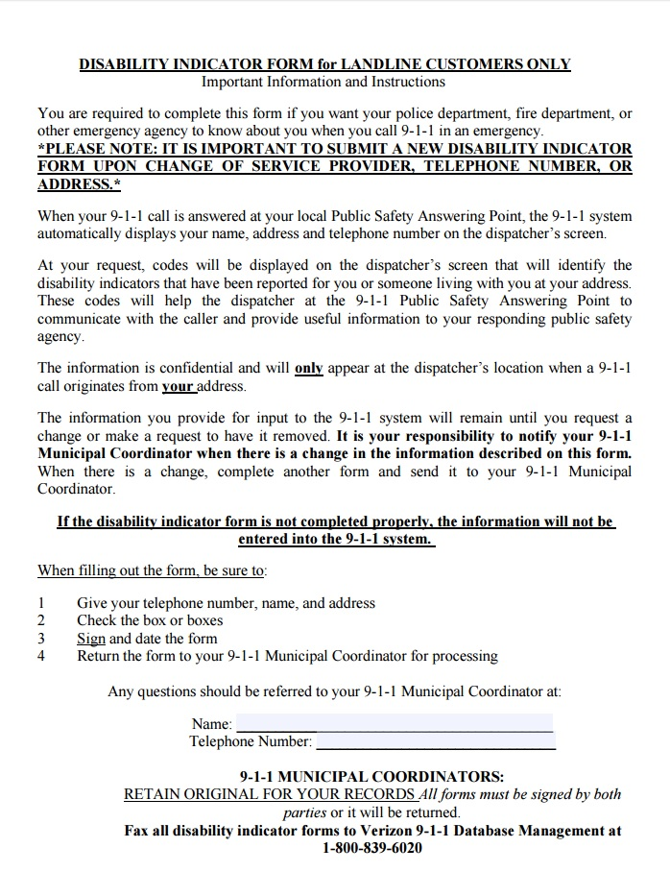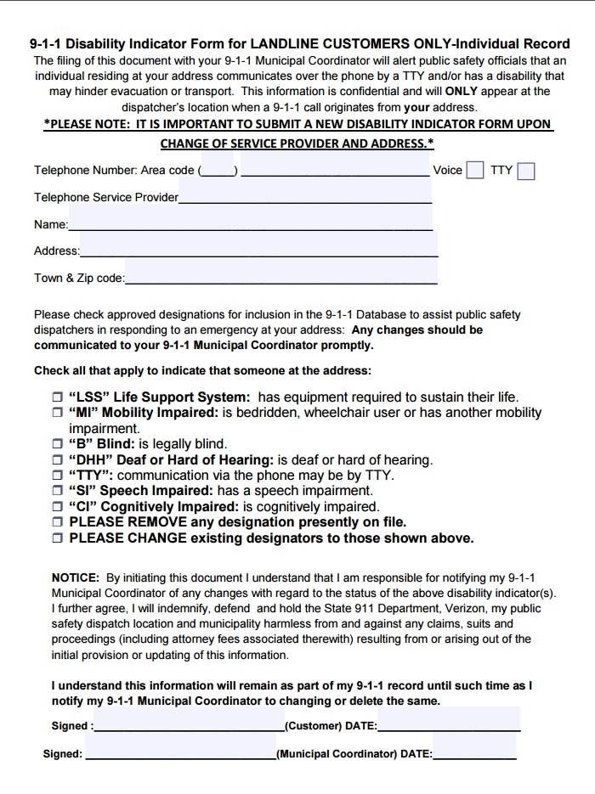
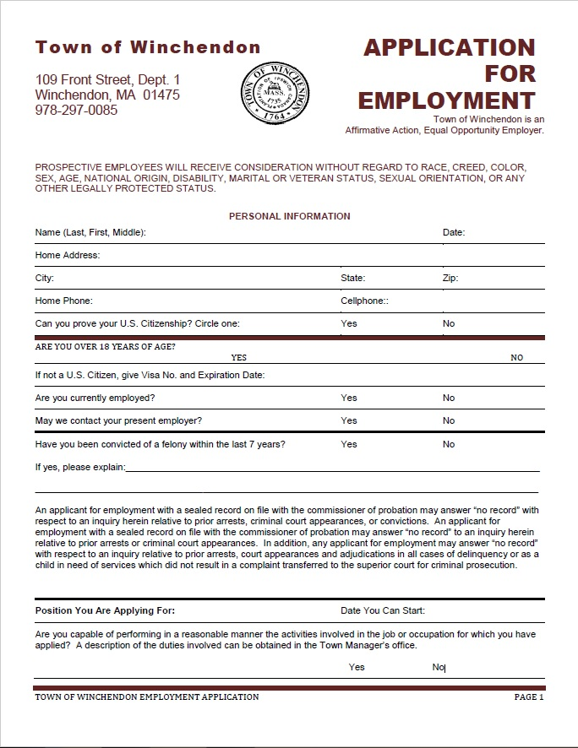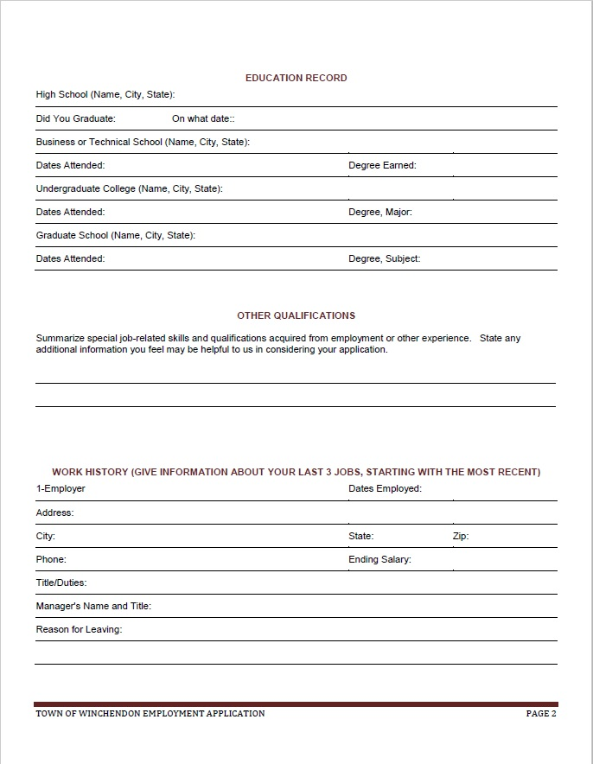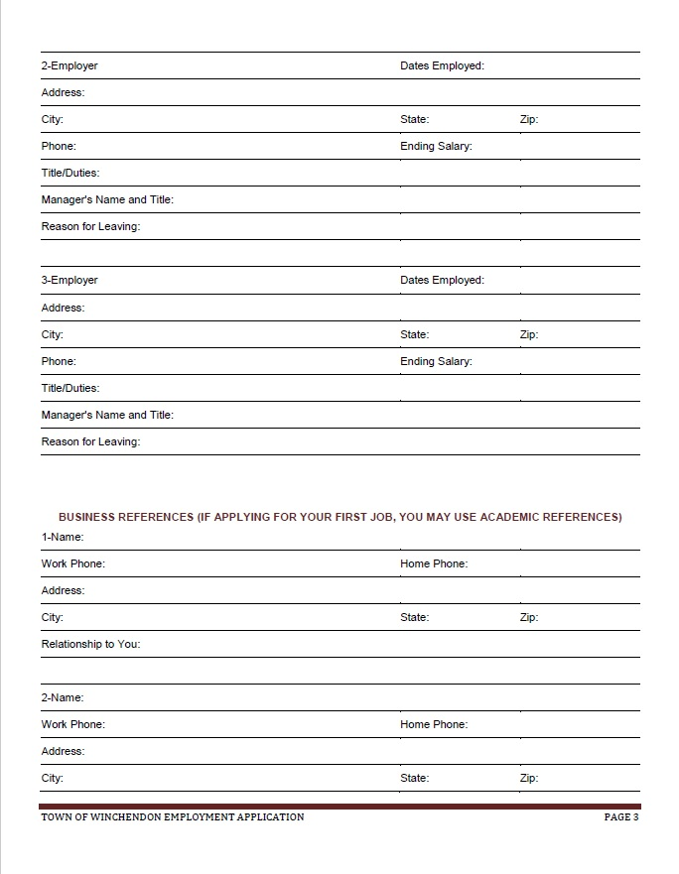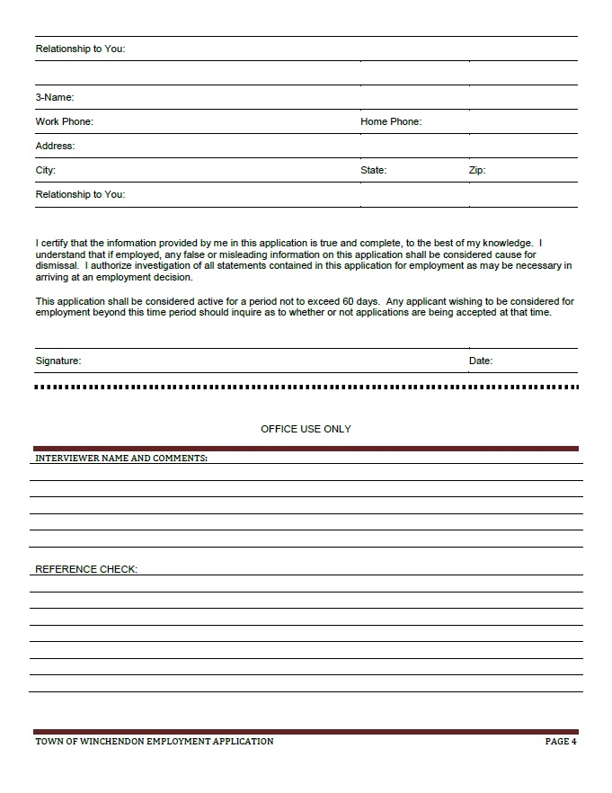

Resources

Communications

Massachusetts Association for the Blind
200 Ivy Street
Brookline, MA 02146
(617) 738-5110 Voice
(617) 731-6444 TDD
Provides large print, Braille, and recording services

Massachusetts Commission for the Deaf and Hard of Hearing
Interpreter/CART Referral Service
150 Mt. Vernon Street, Fifth Floor
Boston, MA 02125
(617) 740-1600 Voice
(617) 740-1700 TTY
Provides referral services for sign language, spoken English, oral, tactile and close vision interpreting for Deaf and Deaf-Blind individuals. Provides referral service to freelance CART providers for CART provision on behalf of hard hearing and/or deafened individuals.

CAPS Educational Collaborative
Mr. Bob Foley
53 School Street
Gardner, MA 01440
(978) 632-2208
Provides sign language interpreters and technical expertise for physical disabilities

Transport

Winchendon Ambulance Service
405 Central Street
Winchendon, MA 01475
In case of Emergency dial: 911
Non-emergency contact (978) 297-2323

